Company XYZ / Sales Projection

EXECUTIVE SUMMARY

# Overview

**Company XYZ** owns a supermarket chain across the country. Each major branch located in 3 cities across the country recorded sales information for 3 months, to help the company understand sales trends and determine its growth, as the rise of supermarket competition is seen to increase.

# The Problem

* Growth increase in the 3 major branches.

# The Solution

* Data interpretation from 3 month sales record from the 3 major branches.
* Provision of insights and recommendation from the data interpretation.

# Highlights

Branch A recorded the highest sales, while Branch C recorded the lowest (fig1).

It was observed that fashion accessories had the highest sales of all product lines, while health and beauty had the least sales (fig 2).

Branch A & C have the highest rating of the 3 major branches (fig3).

Other key highlights are below.

* Total amount sold by the company for the past 3 months is N116,268,029.64000002.
* Lagos has the highest sales at 340, while Port Harcourt has the lowest sales at 328.
* Epay payment was the most used at 345, while Card payment was the least at 311.
* Fashion accessories sold more at 178, while Health and beauty had the least sales at 152.
* Port Harcourt city has the highest gross income at N1,895,463.54, while Abuja has the least at N1,820,531.52.
* Branch A recorded the highest sales, while Branch C recorded the lowest.
* Cash payment was used mostly for electronic accessories purchase.
* Dominant mode of payment in Branch A is Epay while for Branch B its card payment and Branch C its cash.
* Females purchase more of home and lifestyle products, while males purchase more of health and beauty products.
* Product with the highest purchase is home & lifestyle done by females, followed by food & beverages.
* Electronic accessories and Home/Lifestyle products sold the highest quantity

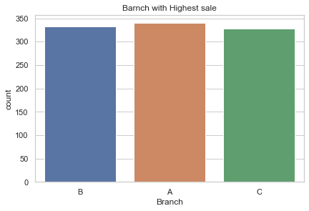

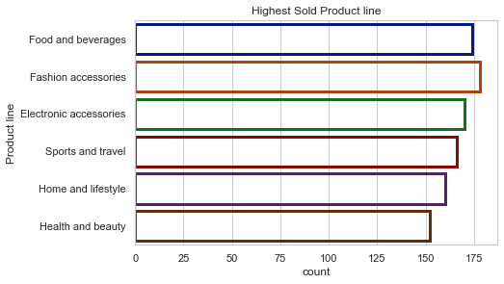

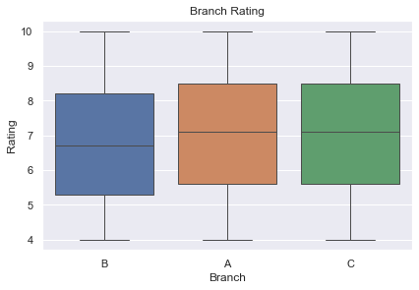

# Keys to Success

* Introduce more of the highest selling product line in the branch with lowest sales.
* Introduce the working sales culture from the branch with the highest sales in the branch with the least sales, this will improve sales.
* Encourage Epay payment option in all branches to ensure customers are not limited by cash.